**USE CASE STUDY REPORT**

**HOSPITAL MANGEMENT SYSTEM**

**Study Group : 4**

**Submitted By : Mina Kazemi, Kiran Priya Chigurupati, Priyanshi Rastogi**

* **Introduction**
* **Conceptual Data Modeling**
* **Mapping Conceptual Model to Relational Model**

**Relational Model:**

administrator( adminid , adminname , loginid , password , status , usertype)

patient( patientid , roomid , doctorid , patientname , admissiondate , admissiontime , address , mobileno , city , pincode , loginid , password , bloodgroup , gender , dob , bed_allottment , status)

appointment( appointmentid , *patientid* , roomid , departmentid , doctorid , appointmentdate , appointmenttime , status , app_reason)

billing( billingid , *patientid* , doctorid , appointmentid , billingdate , billingtime , discount , taxamount , discountreason)

billing_records( billingservice_id , bill_type_id , bill_type , bill_amount , bill_date , status)

department( departmentid , medical_practice , status)

patient_medical_conditions( *patientid* , medical_history)

doctor( doctorid , doctorname , mobileno , departmentid , loginid , password , status education , experience , consultancy_charge , no_of_patients_yearly)

doctor_timings(doctor_timings_id , doctorid , start_time , end_time , status)

medicine(medicineid , medicinename , medicinecost , description , status)

orders(orderid , patientid , doctorid , prescriptionid , orderdate , deliverydate , address , mobileno , note , status )

payment( *billingid* , paymentid, *patientid* , appointmentid , paiddate , paidtime , paidamount , status , payment_method )

prescription( prescriptionid , treatment_records_id , doctorid , patientid , delivery_type , delivery_id , prescriptiondate , status , appointmentid )

prescription_records( prescription_record_id , *prescriptionid* , medicine_name , cost , unit , dosage , status

room( roomid , roomtype , noofbeds , room_tariff , status )

service_type( service_type_id , service_type , servicecharge , description , status )

treatment( treatmentid , treatmenttype , treatment_cost , note , status )

treatment_records(treatment_records_id , *treatmentid* , appointmentid , patientid , doctorid , treatment_description , uploads , treatment_date , treatment_time , status )

user(userid , loginname , password , patientname , mobileno , email , createddateandtime )

discharge_summary(*patientid* , discharge_details , discharge_time)

Primary keys are underlined, Foreign key are in italics

* **Implementation of Relation Model via MySQL and NoSQL**

**Implementation in MySQL**

Query 1 : Display all patients below the age of 18 along with their medical history

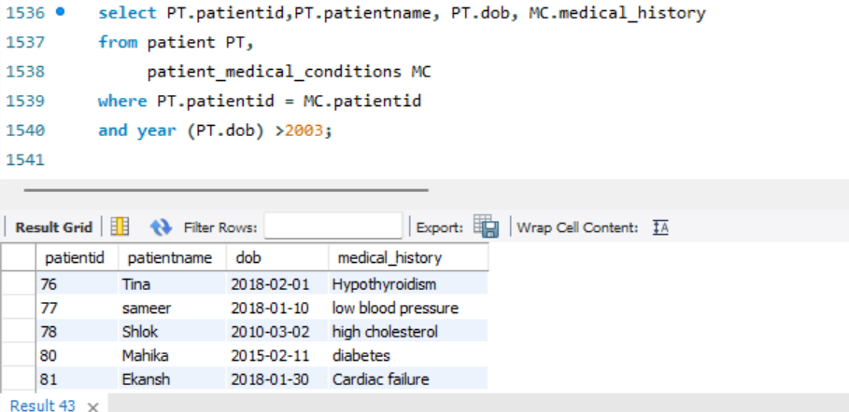

Query 2 : Display all patients who have cashless insurance and have paid bills greater than 50000 to the hospital via cashless insurance payment method and which doctors assisted them in their treatment

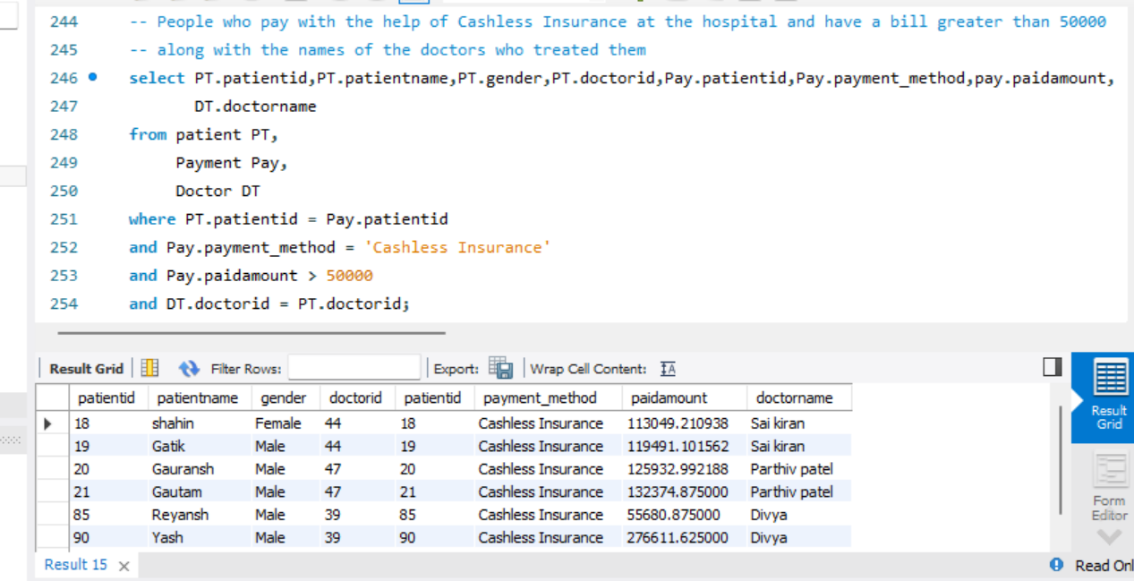

Query 3 : Count of all patients in the general ward who have received bed allotment vs who have not received bed allotment

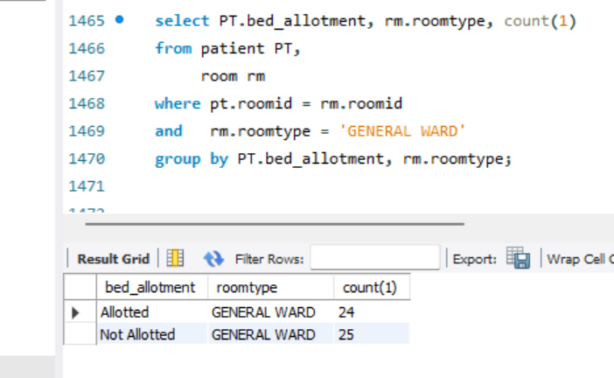

Query 4 : Percentage of patients who have a medical history of high cholesterol and heart disease and have died in the hospital.

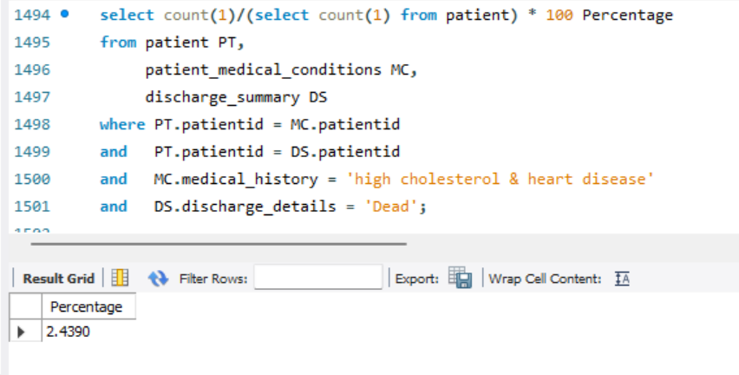

Query 5 : Highest number of patients admitted to the hospital in which month

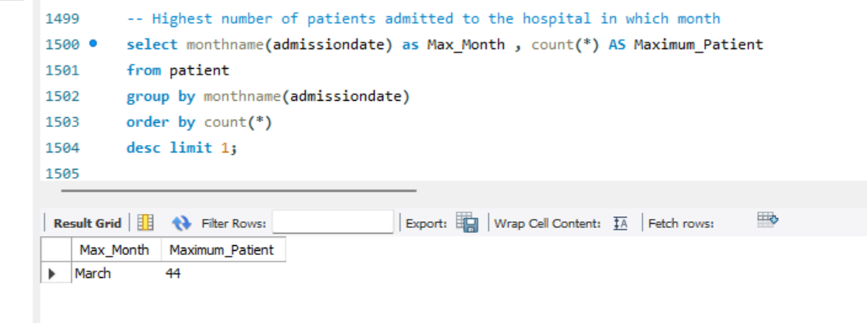

**Implementation in NoSQL using MongoDB**

Query 1 : Retrieve the details of amount paid by the patients via Debit Card in ascending order of payments made

db.Payment.find({payment_method:"Debit Card"}).sort({paidamount: 1})

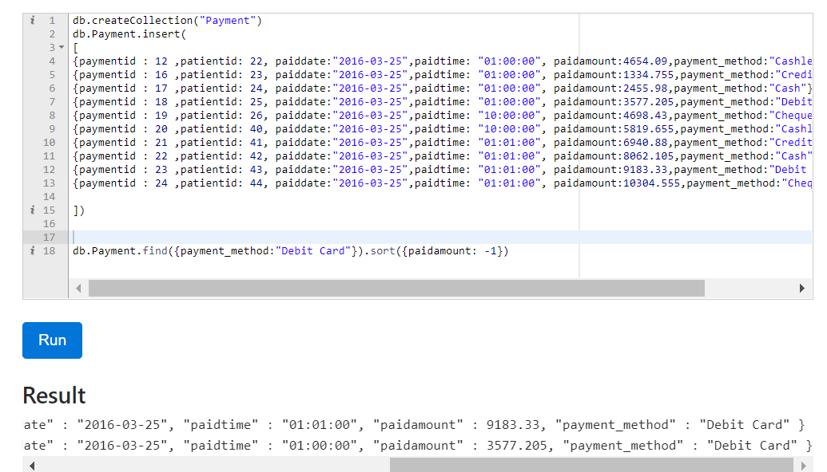

Query 2 : Retrieve the number of patients who paid more than 5000 for their treatment in the hospital

db.Payment.count({paidamount:{$gt:5000}})

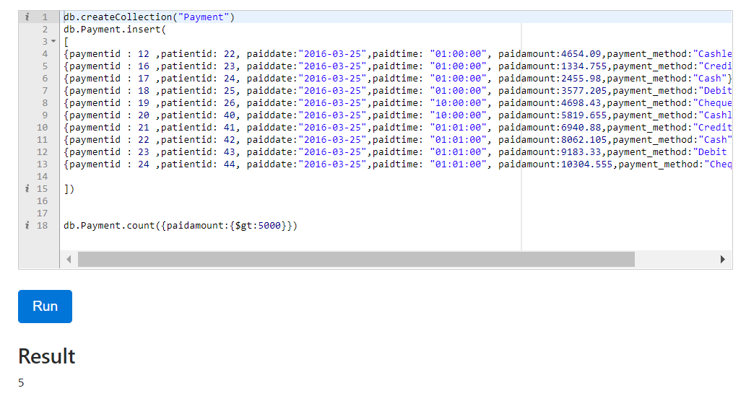

Query 3 : Which patients had a heart failure or have a medical history of cholesterol and heart disease ?

db.Patient_Medical_Conditions.find({$or:[{medical_history:"heart failure"},{medical_history:"high cholesterol & heart disease"}]})

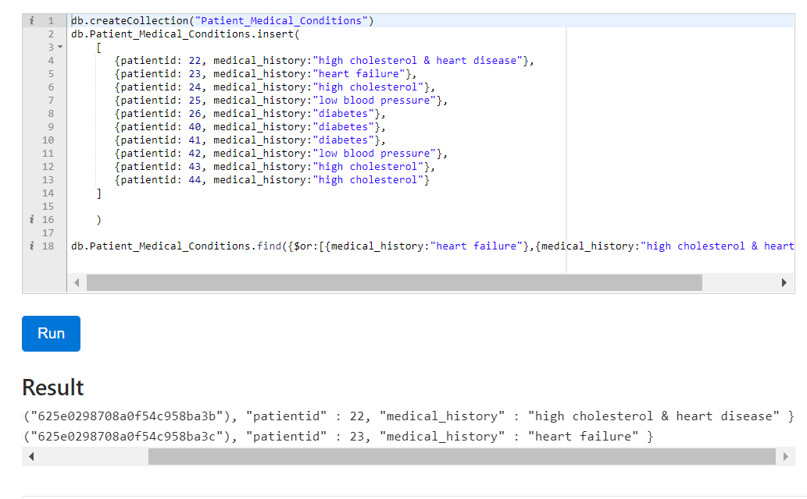

* **Database Access via Python**

Step 1 : Connect to MySQL database

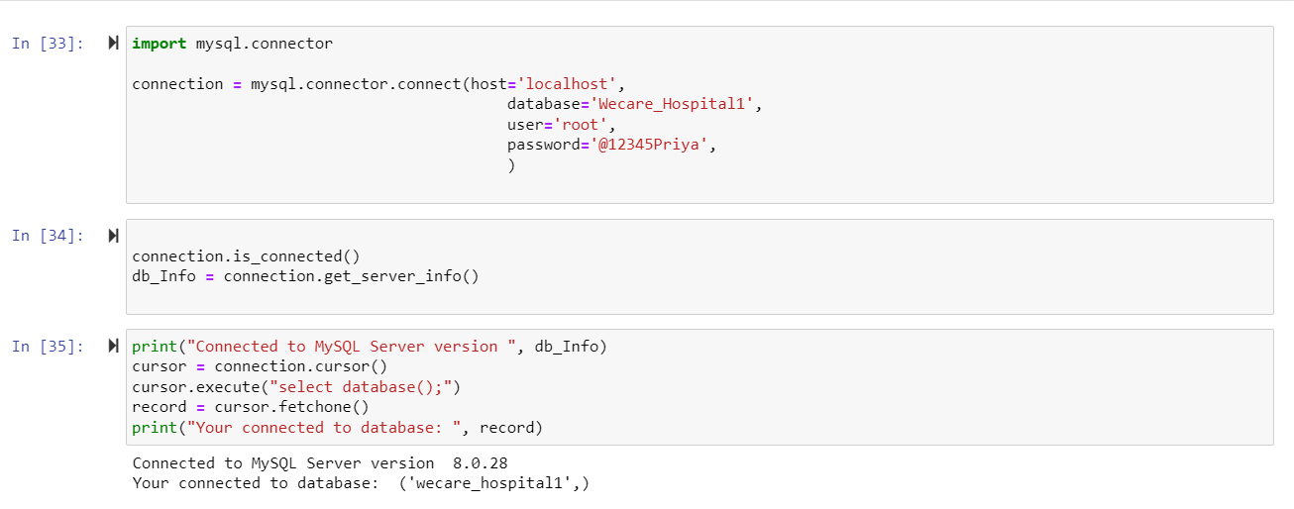

Step 2 : Executing Patients Table

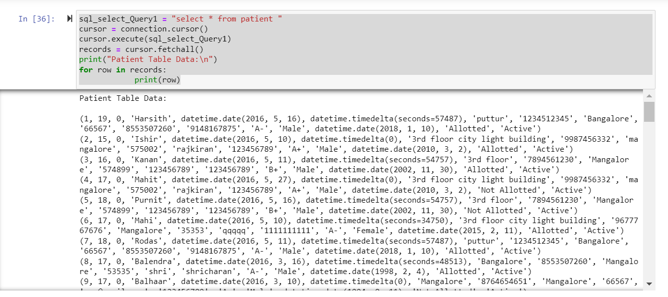

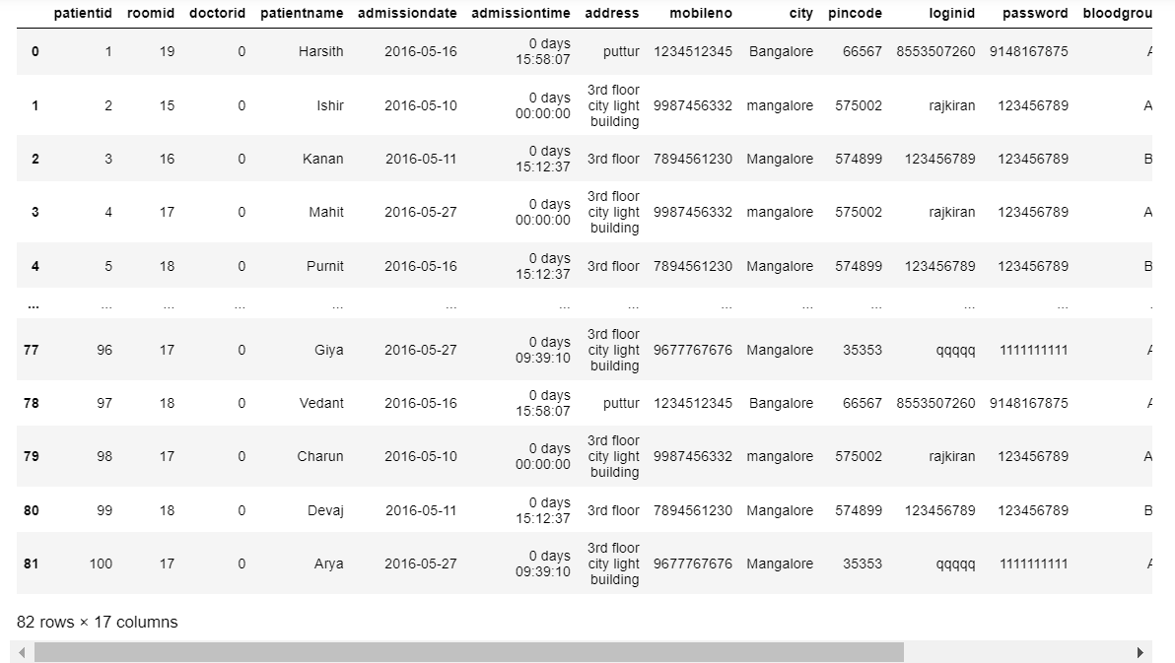

**Step 3 :** Graph 1 – Number of Male Patients vs Number of Female Patients

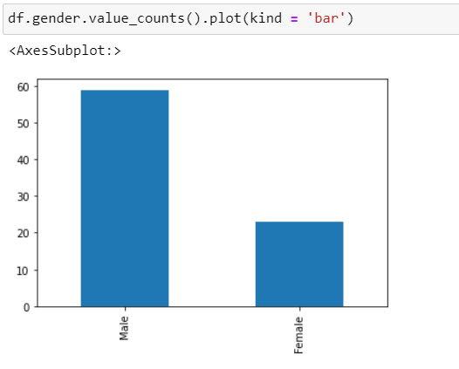

**Step 4 :** Graph 2 – Distribution of blood groups among the patients

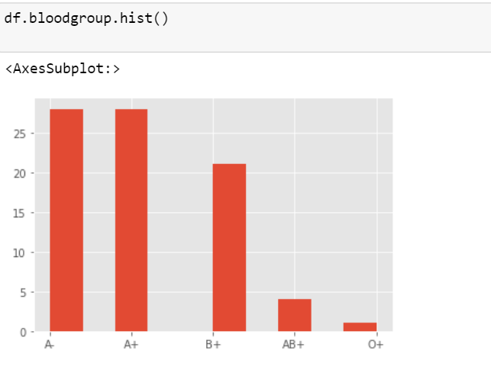

Step 5 : Reading Data from Payment Table

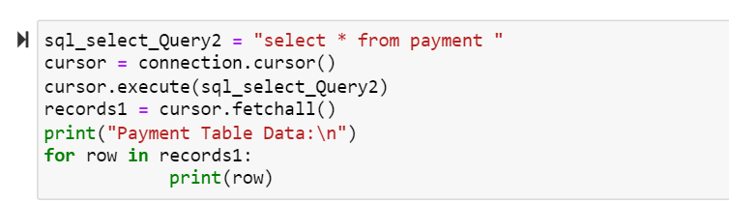

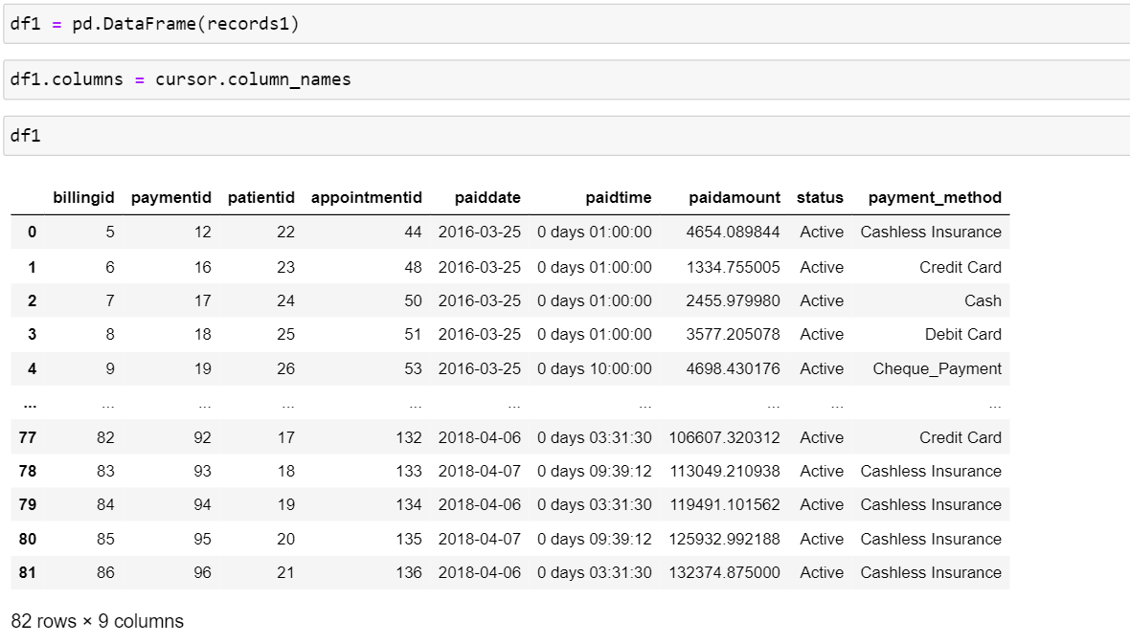

Step 6 : Amount Paid by the customer on a given date

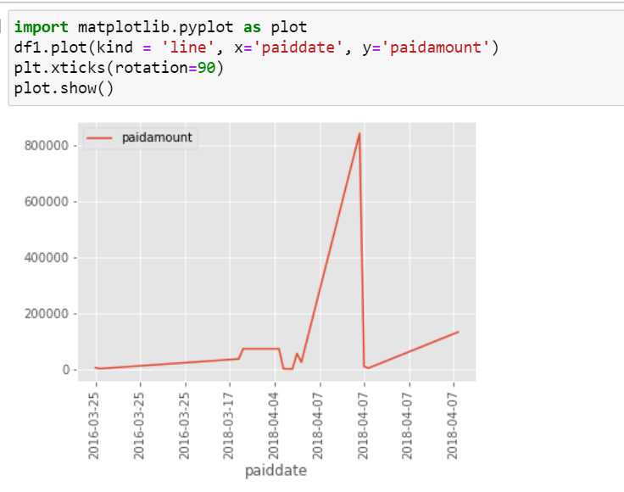

* **Summary and recommendation**